SubModule ‘General Settings’

Description:
This SubModule contains General User Settings, like folders and email.
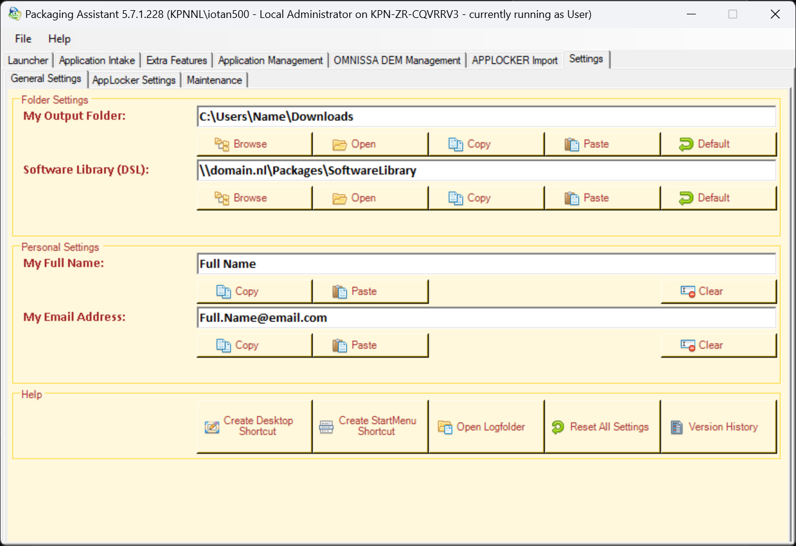

Features:
- Folders Settings: This Feature contains Folder settings used throughout the application.

- Personal Settings: This Feature contains the User’s Personal settings.

- Help: This Feature contains miscellaneous Help functions.

